

Engineering stackup & impedance

**Product No ：W728641AS1C1 Stackup Information:**

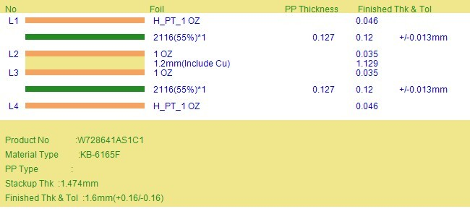

**Impedance Information:**

|  |  |  |  |  |  |  |  |  |  |  |  |
| --- | --- | --- | --- | --- | --- | --- | --- | --- | --- | --- | --- |
| index | Imp style | CTL | REF | OrigTr | OrigS | origG | AdjTrace | AdjSpace | AdjGaurdi | Cust Imp | CALC imp |
| 1 | Single-ended | L1 | L2 | 6.69 |  |  | 7.49 |  |  | 50 | 50+/-5Ω |
| 2 | Single-ended | L4 | L3 | 6.69 |  |  | 7.49 |  |  | 50 | 50+/-5Ω |
| 3 | Differential | L1 | L2 | 6.69 | 8.31 |  | 7.29 | 7.71 |  | 90 | 90+/-9Ω |